**Summer Reading Prizes**

**All Age Prizes (0-18)**

1. **Spiderman Art By Numbers**

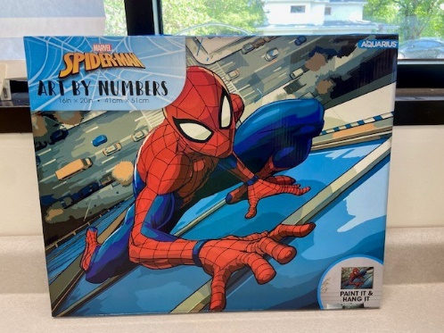

1. **Thor’s Hammer Puzzle with Crystal Tree and Touchabubbles**

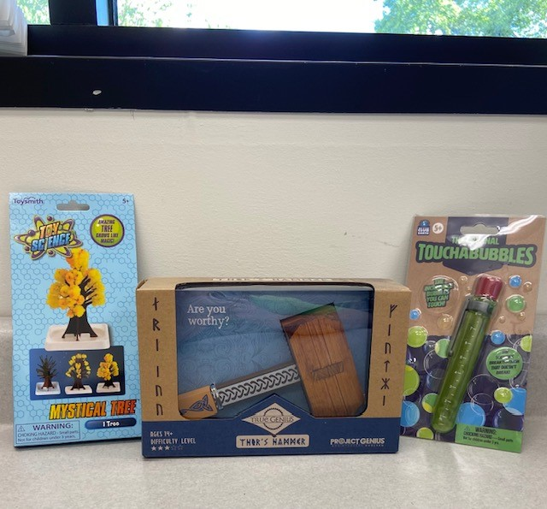

1. **Trash Pandas Card Game with Crystal Tree and Touchabubbles**

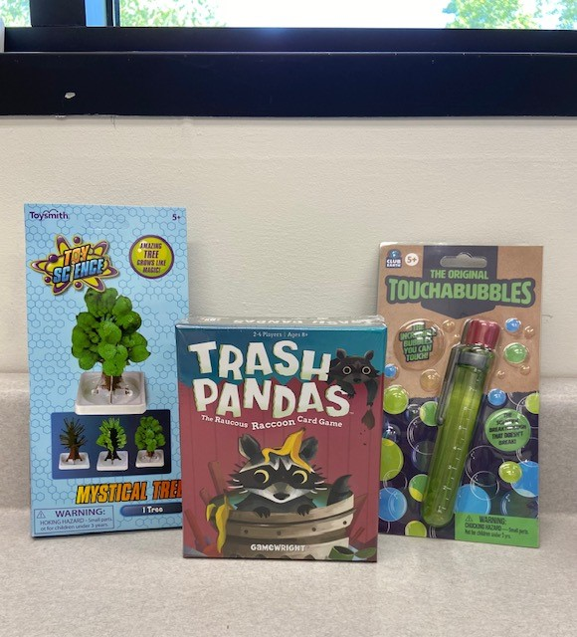

1. **Soundblaster All Weather Speaker**

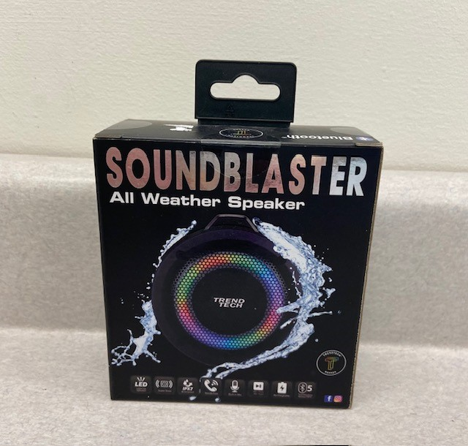

1. **Jabbit Outdoor Sport Set**

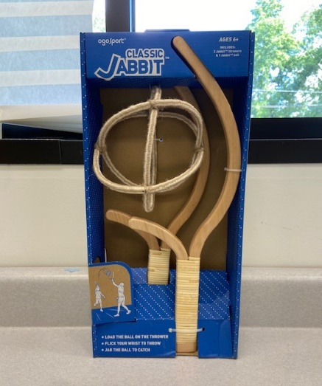

1. **Bingsu Ringz**

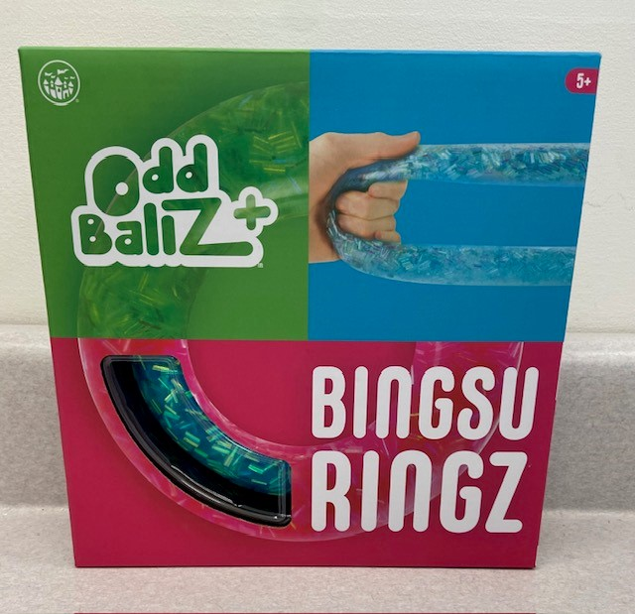

1. **Knit it! Set**

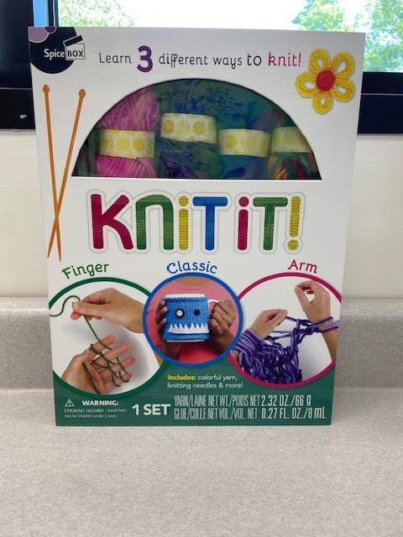

1. **Mystery Squishmallow with HamSta Shoe Charms**

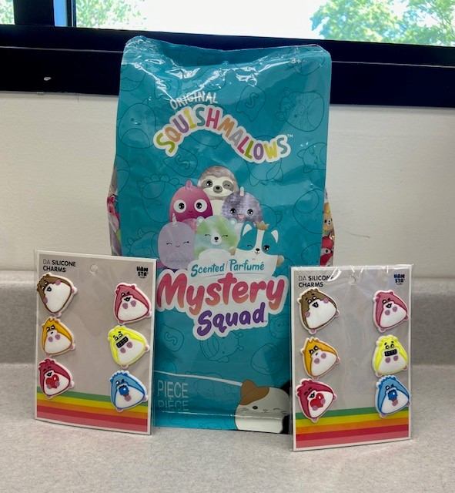

1. **Purple Monster Micro Kite with Butterfly Slime Mix**

**(Contains Gluten)**

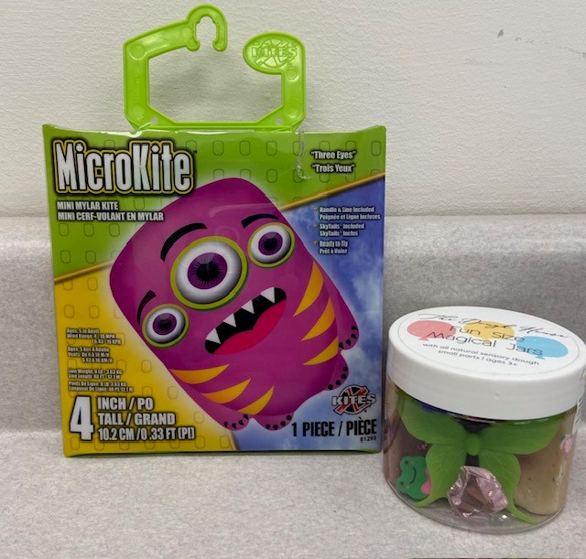

1. **Pink Monster Micro Kite with Dinosaur Slime Mix**

**(Contains Gluten)**

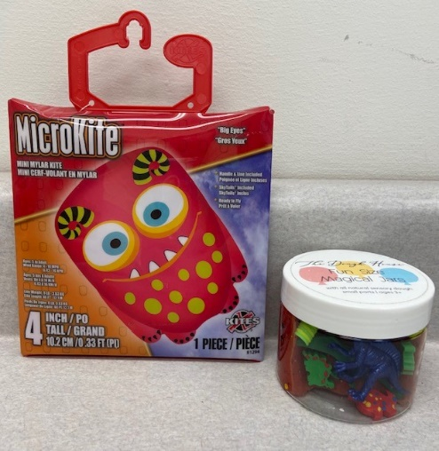

1. **Orange Monster Micro Kite with Animal Slime Mix**

**(Contains Gluten)**

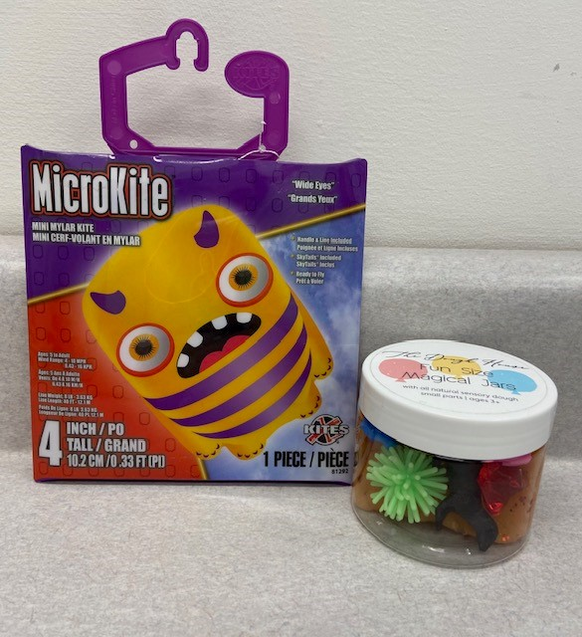

1. **Dissect It Frog Lab Kit**

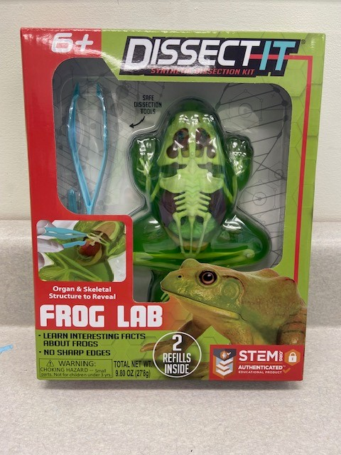

1. **Sunhiker Backpack with Indiana State Park Pass and Water Bottle**

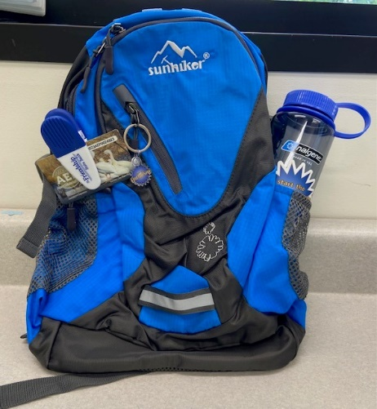

1. **Tempest Blue & Pink Bike**

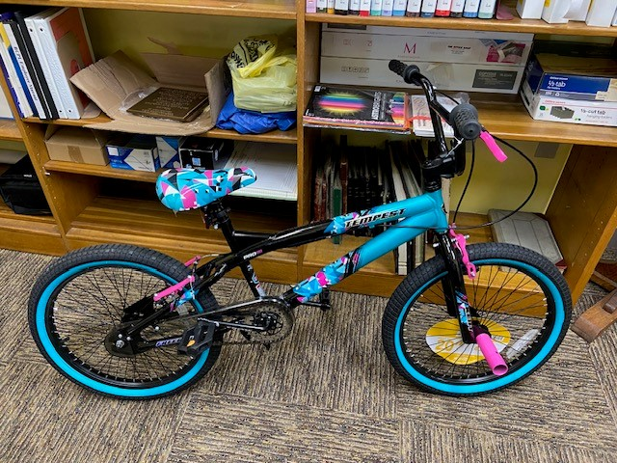

1. **Schwinn Black & Orange Bike**

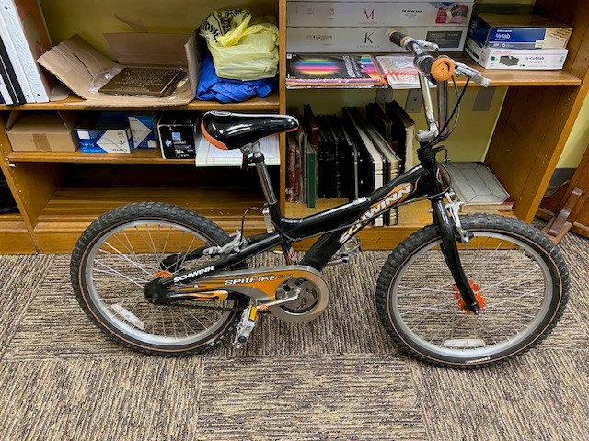

**12 & Under Prizes**

1. **Clixo Magnetic Building Set with Crystal Tree and Touchabubbles**

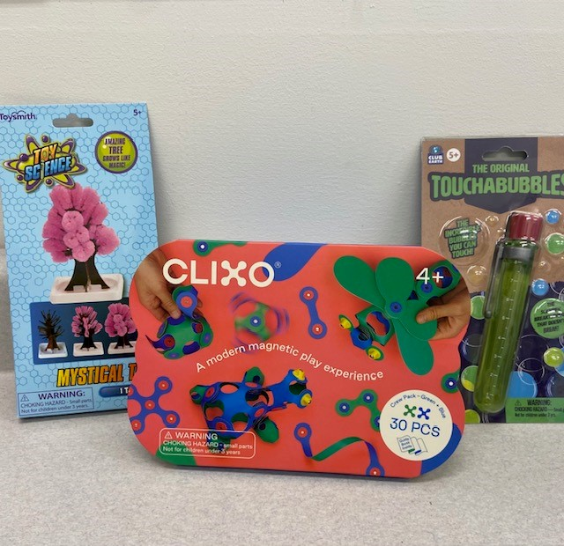

1. **Suction Sphere Ball with Avatar Socks**

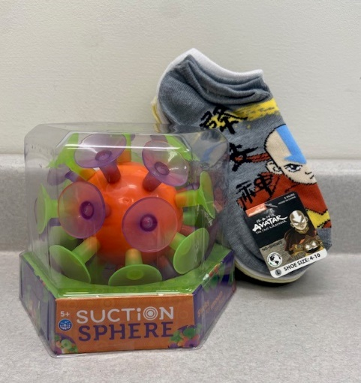

1. **AirFort**

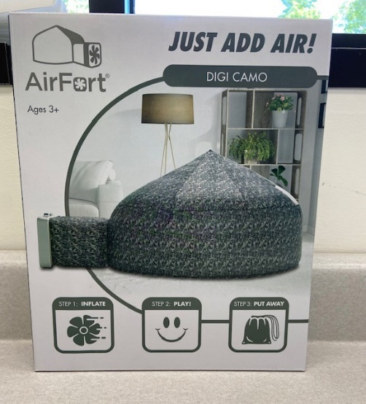

1. **Melissa & Doug Cutting Fruit Set**

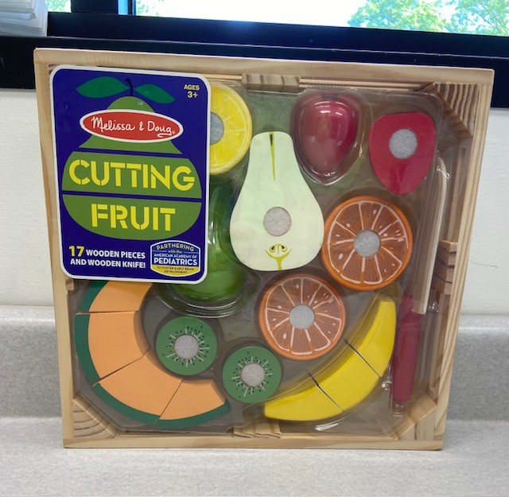

1. **Melissa & Doug Ice Cream Shop Chalk Set**

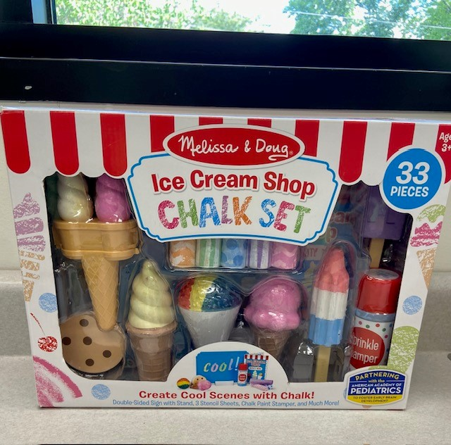

1. **Sensory Bathy Mobile**

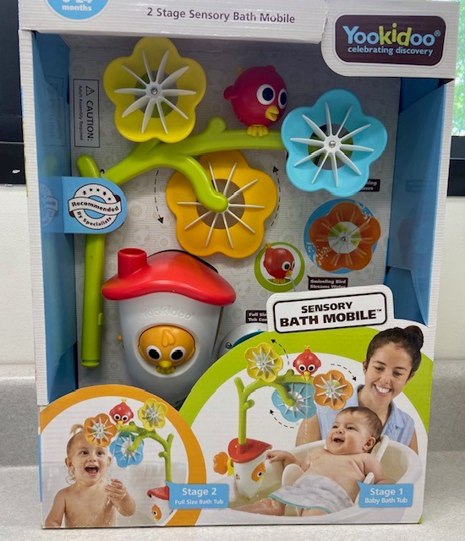

1. **Hand Puppets**

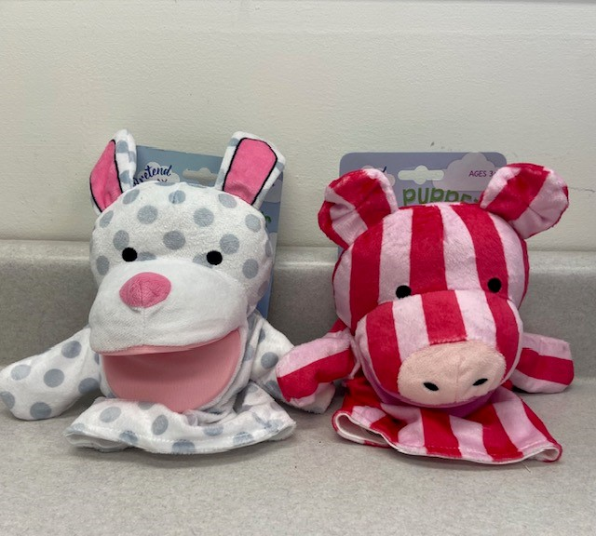

1. **Laura Numeroff’s “If You Give a Mouse a Cookie” Book with Mouse Plush**

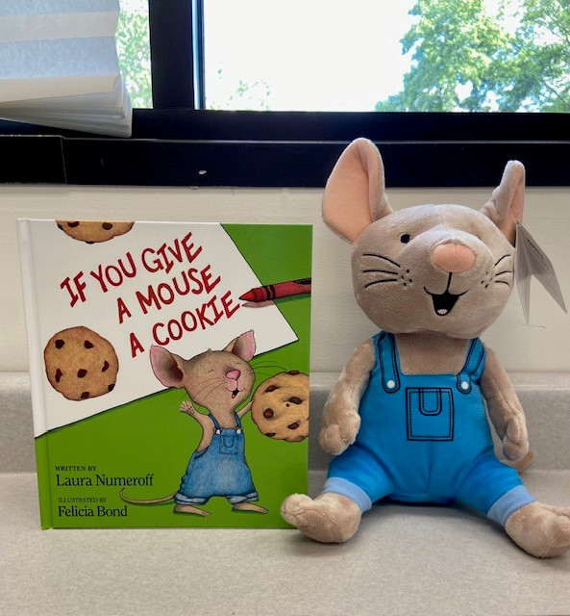

1. **Kids Robotix Motorized Robot Hand with Crystal Tree**

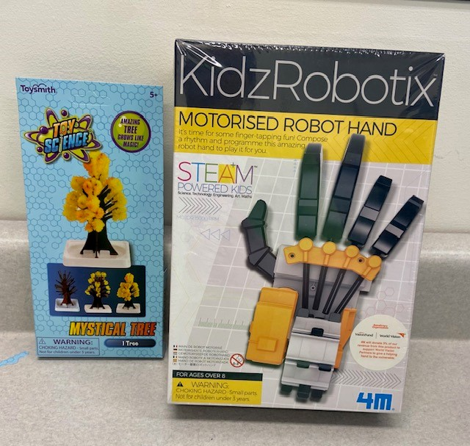

1. **Young Artist Learn to Paint Set**

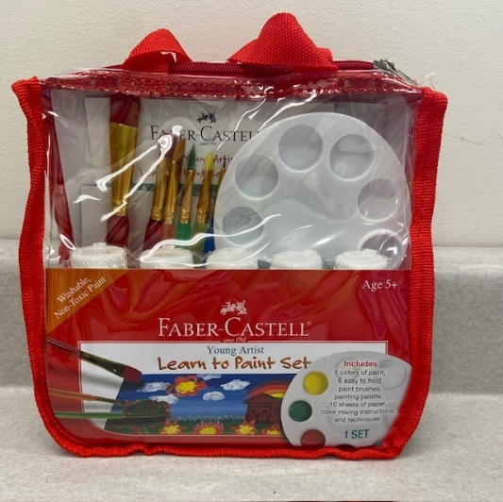

1. **Bead Spinner Bracelet Maker**

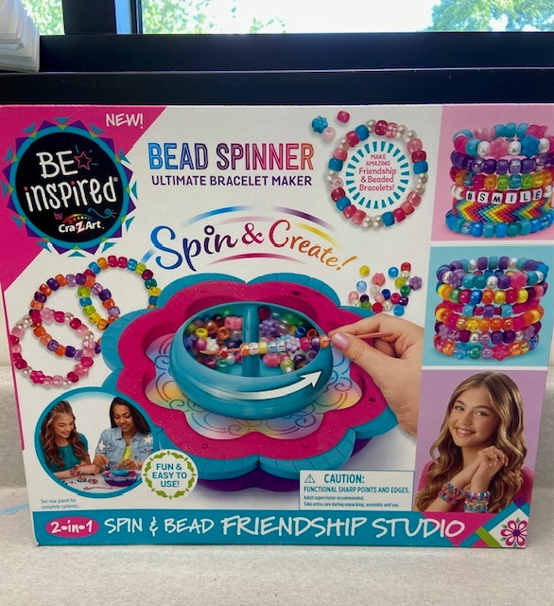

1. **Melissa & Doug Play Money Set**

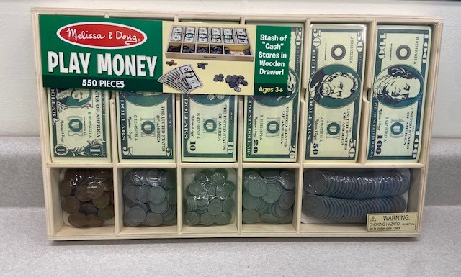

1. **Dog Man Attack of the Fleas Game**

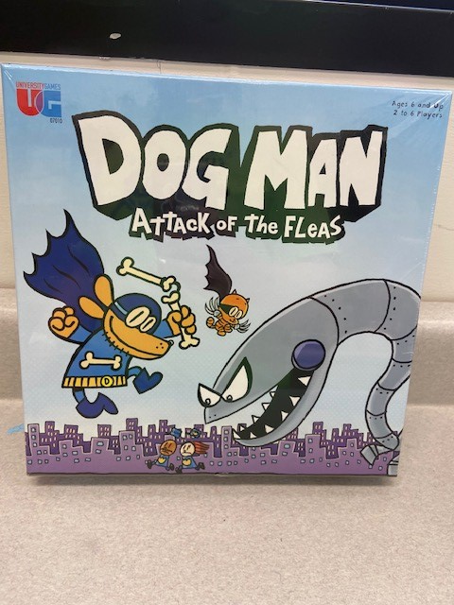

1. **The Three Little Pigs Book and Play Set**

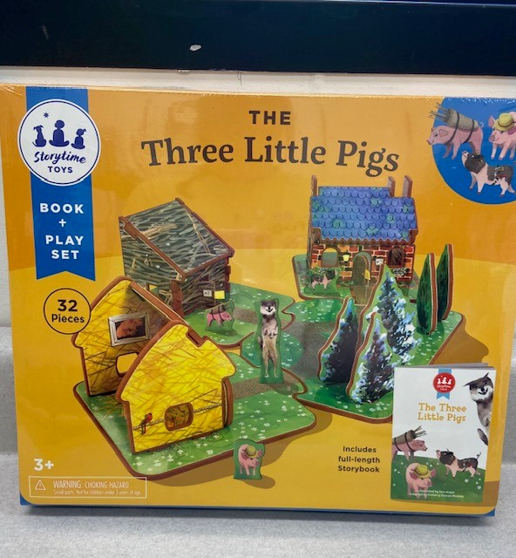

1. **Care Bears Collector Set**

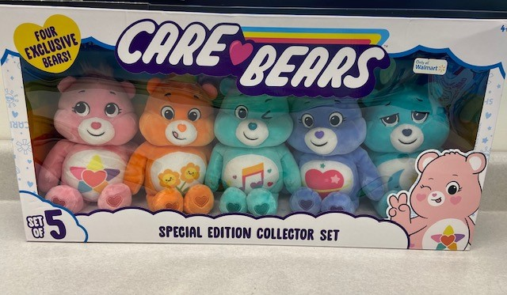

1. **Glamour Girls Styling Center**

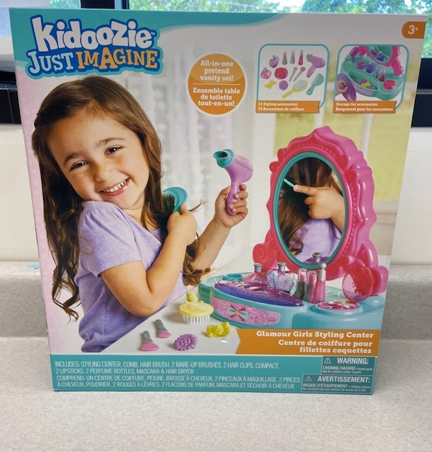

**13+ Prizes**

1. **D&D Starter Set with Dice Tower**

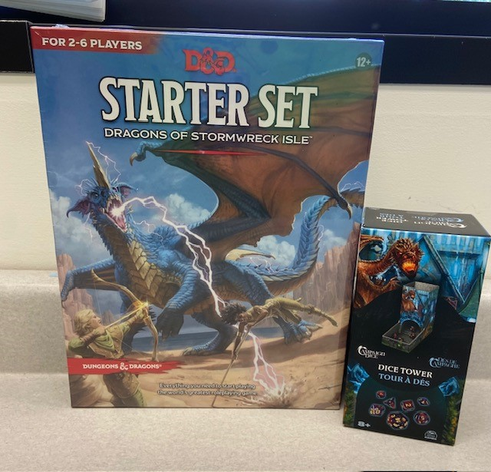

1. **Spy Family Notebook with Panda Stickers and Ramen Sticky Notes**

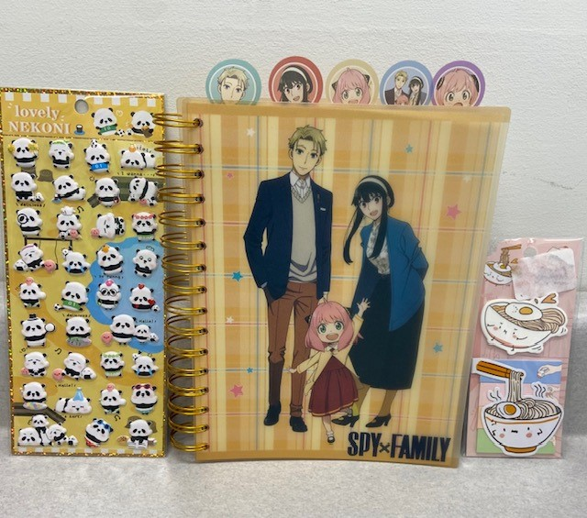

1. **Playstation Icons Light**

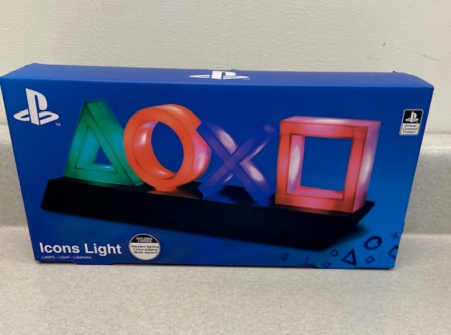

1. **Demon Slayer Mug with Demon Slayer Mystery Figure**

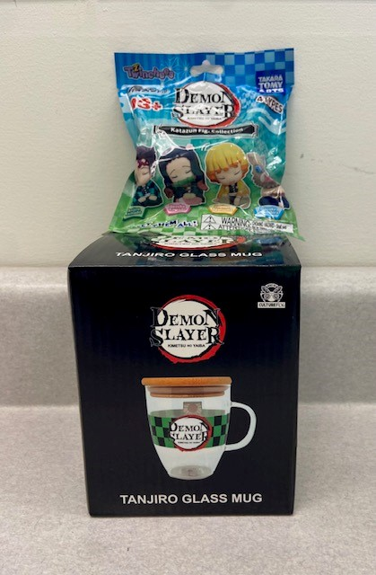

1. **Death Note Socks with Chainsaw Man Lanyard and Boba Air Freshener**

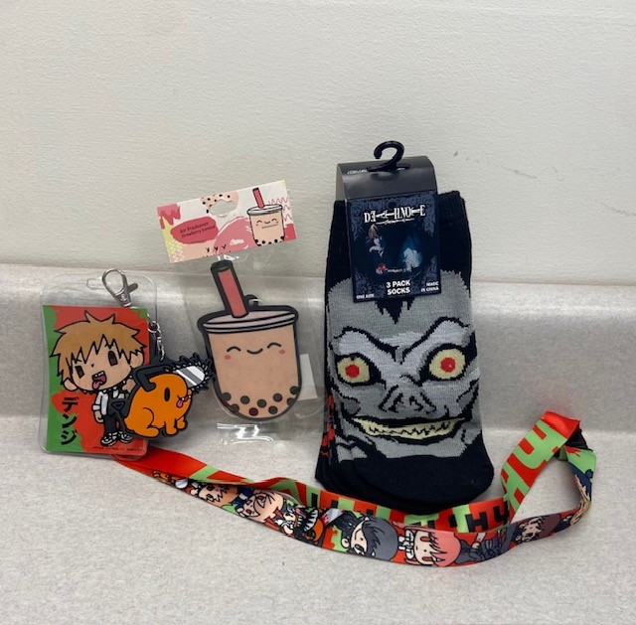

1. **My Hero Academia Ramen Bowl with Sriracha Ramen and Ramen Sticky Notes**

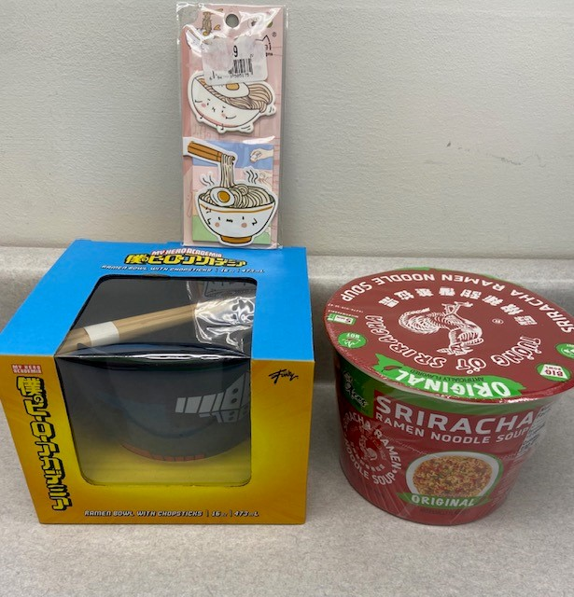

1. **Draw Your Own Manga Kit**

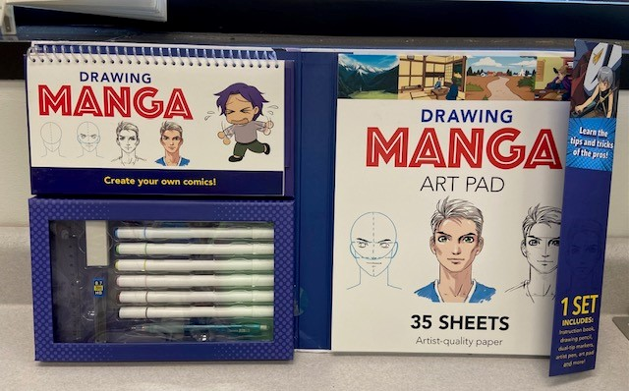

1. **Spicy Dried Squid Snack, Spicy Watermelon Gummies, Tropical Mochi, and Ramune**

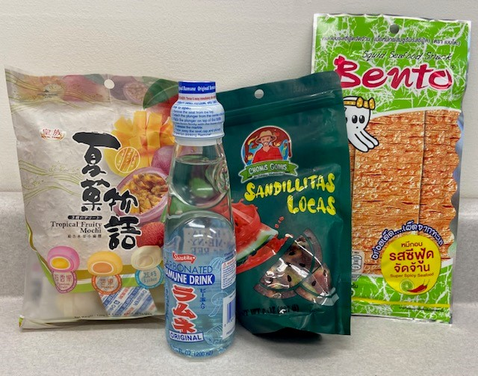

1. **Dried Squid Snack, Hi Chew Candy, Popin’ Cookin’ Hamburger Candy Kit, and Pear Ramune**

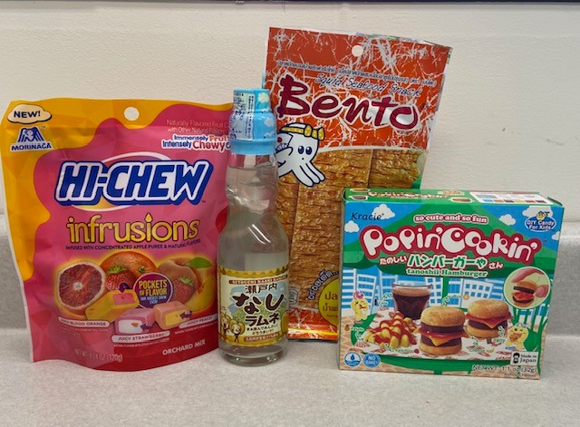

1. **Spy Family Blanket with Demon Slayer Mystery Figure**

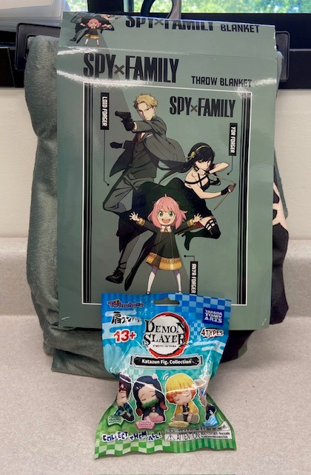

1. **Quick Switch Power Bow**

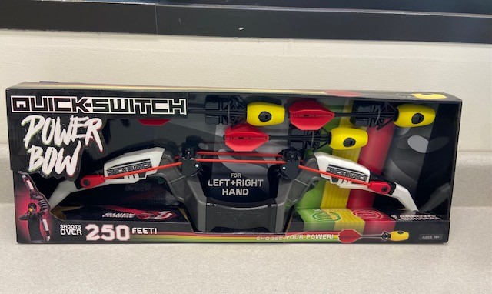

1. **$25 Taco Bell Gift Card**

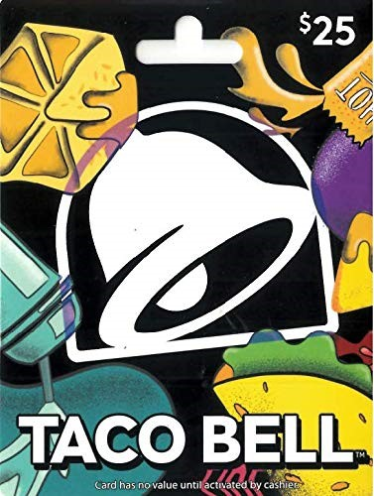

1. **$25 Starbucks Gift Card**

